Outcome C Review
Name: ________________________ Period: ________________
Use your textbook, notes, and terms to complete the following. Although this study guide is comprehensive, don’t forget to review your notes and terms as well.
Part 1: Identify each statement or demographic as typically associated with the Democratic (D) or Republican (R) Party.
- ___Protect the Environment
- ___Pro-life
- ___Gun Rights
- ___Typically Minorities
- ___Typically living in Cities
- ___Gun Control
- ___Favor personal liberties
- ___More Conservatives
- ___Higher taxes on the wealthy
- ___Pro Federal Health Care
- ___Pro Public Morality
- ___The GOP
- ___Symbol is a Donkey
- ___Pro-Big Business
- ___Typically White Collar Workers
- ___Typically live in rural areas
- ___Typically Younger
- ___In favor of less taxes
- ___Symbol is the Elephant
- ___Pro-Choice
- ___Limited National Government
- ___More Liberal
- ___CNN/MSNBC
- ___Fox News

Part 2: Voting Rights: use amendments and laws to fill in the following related to the expansion and protection of the right to vote

- The ________________________ eliminates discrimination based on sex when voting.
- The ________________________ eliminates poll taxes at the voting booths.
- The ________________________ eliminates discrimination based on race when voting.
- The________________________ extend the right to vote to Washington D.C.
- The _________________________ is federal policy that enforces the 15th amendment.
- __________, _____________, _____________ were the 3 characteristics of the framers’ original voting “citizens”.


Part 3: Electoral College FACTS, Fill in the BLANK.
- How many votes are needed to win the Electoral College? ________________________
- There are how many electoral votes total in the United States? ____________________
- Which state has the most electoral votes? How many votes? ______________________
- If there is a tie in the E.C., who decides who is President? _________________________
- How many electoral votes does Illinois have? __________________________________
- Number of representatives plus senators determines what? ______________________
- If a state has 29 electoral votes, how many representatives does it have? ___________
- If a state has 18 electoral votes, how many senators does it have? ________________
- If a Mr. Jones wins 40% of a state’s popular votes and the next closest candidate only wins 35%, how many of the state’s electoral votes does Mr. Jones receive? ___________
- Washington D.C. has how many electoral votes? ________________________________
- Can a candidate can win the presidential election without winning California? Explain.

- States that do not always give their electoral votes to a certain party’s candidate but switch from election to election are called: ____________________________________
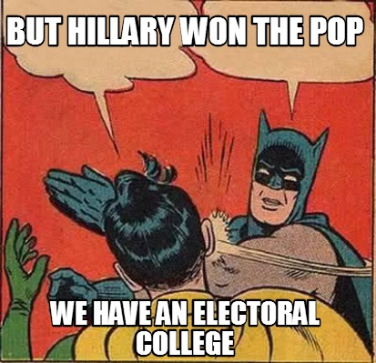

Part 4: PACs VS Super PACs
Fill in the BLANK using PAC or Super PAC
- ______________________ | - ______________________
- Can only donate:  - $5,000 per candidate per election  - $15,000 to a party per year  - Money given directly to candidates  - Must report their donations | - Can donate unlimited amounts of money  - Money cannot be given directly to candidates  - Can be spent to publish information about a candidate  - Donations can be anonymous

What Supreme Court decision led to the rise of Super PACS? ____________________________
Part 5: Political Spectrum: Place the following ideologies on the Political Spectrum below: liberal, conservative, moderate
_______________ _______________ ________________

__________ __________ __________ __________ __________

The political spectrum shows a RANGE of views, not distinct categories…place the following viewpoints on the spectrum above.
- Abortion should always be illegal.
- Abortion should be legal in all circumstances.
- Abortion laws are fine as they are, there should be some restrictions but a woman’s right to choose should be supported.
- Abortion laws should be loosened to give women more choice. Some states are too strict.
- Abortion laws should be tightened to protect women and unborn children.

PART 6: Interest Groups - Explain what an interest group is and what role they play in our government:

List at least three examples of interest groups:

PART 7: Participation in Government

- What are the requirements to vote in Illinois:

- Name at least three methods/ways you can register to vote in Illinois:

- Name at least 3 ways citizens can participate in our democracy:

- Explain how one of the above demonstrates ACTIVE citizen participation.

Third Parties in America


