Gummy Governments
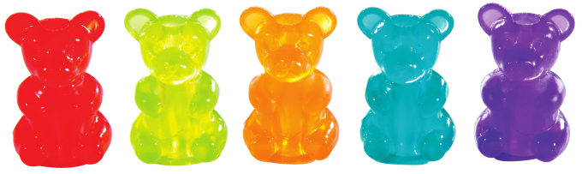

Autocracy (Rule by 1)

- Monarchy – (absolute & constitutional) a government in which the supreme power is lodged in the hands of a monarch who reigns over a state or territory, usually for life and by hereditary right; the monarch may be either a sole absolute ruler or a sovereign - such as a king, queen, or prince - with constitutionally limited authority.

- Dictatorship - a form of government in which a ruler or small clique wield absolute power (not restricted by a constitution or laws). People are powerless.
3. Oligarchy (Rule by small group) a government in which control is exercised by a small group of individuals; authority generally is based on wealth or power.

- Communist - a system of government in which the state plans and controls the economy and a single - often authoritarian - party holds power; state controls are imposed with the elimination of private ownership of property or capital while claiming to make progress toward a higher social order in which all goods are equally shared by the people (i.e., a classless society).

- Theocracy - a form of government based on religion, in which a Deity is recognized as the supreme civil ruler, but the Deity's laws are interpreted by authorities (bishops, mullahs, etc.); a government subject to religious authority.

Democracy (Rule by the People) - a state in which the supreme power rests in the body of citizens entitled to vote for officers and representatives responsible to them.

- Direct Democracy- People all vote directly on every issue (best in very small communities or early American societies)

- Representative Democracy – People elect representatives to vote on their behalf and “represent” them in government.

Others? Consult the handout provided or the internet and read about other forms. You must re-create at least 1 additional form of government.
Task:

- Using Gummy Bears and any props available (or which you create), you are to create models of each of the above forms of government.

- Have one person in your group take a photo of each of the models before you take them apart. You will need to email these to yourself so you can include them on your slides.

- Create a photo essay of your models and upload them into a powerpoint presentation which you share with me. Share your presentation with your group so that you are working on the project together.

- Within the Presentation, using the writing tools, you can label, draw more images, explain, etc. your types of government.

- Provide at least one examples of a country which has each form of government and include that information on the appropriate slide.

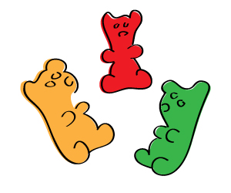

Rubric: You must have a slide for each of the types of government. Assign a group member to create that slide using the photo of the gummy government.

Slide One – Title – “Types of Government” and group member’s names
Slides Two-Eight - One slide for each of the 7 forms of government detailed on this handout, plus the one you choose from the additional resource

Each slide should contain the following:

- Image of the gummy bear government showing that type of government
- Title – Type of Government at top of the slide
- Using image pen, draw/add things to accentuate/improve the picture
- Definition of the Type of Government
- At least ONE example of a country that has that type of government
- Name of the student that created that slide in small print at the bottom of the slide

When you have finished creating and photographing ALL of your models and are satisfied that they are accurate, the group may eat the gummy bears .

