Name: ______________________________________ Period: ______
APGOV: Units IV and V Study Guide
Skills Portion: Can you read and analyze these items? In the white space, provide a short annotation for what the item is about what you can conclude from it.
Item 1:
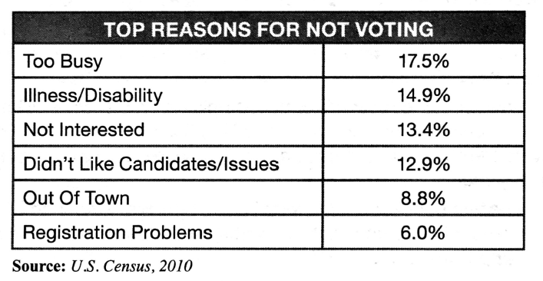

Item 2:
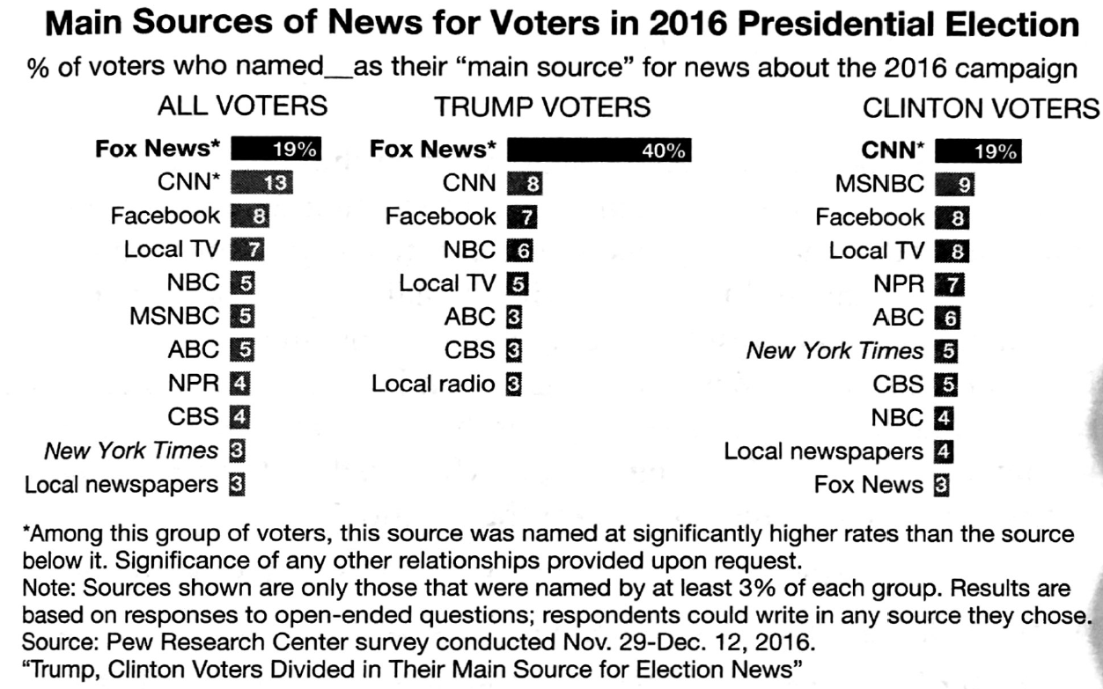

Item 3:
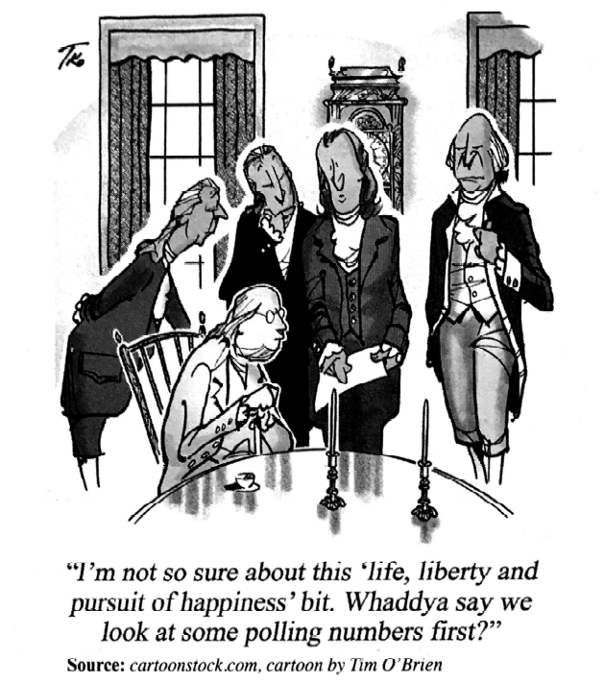

Item 4:
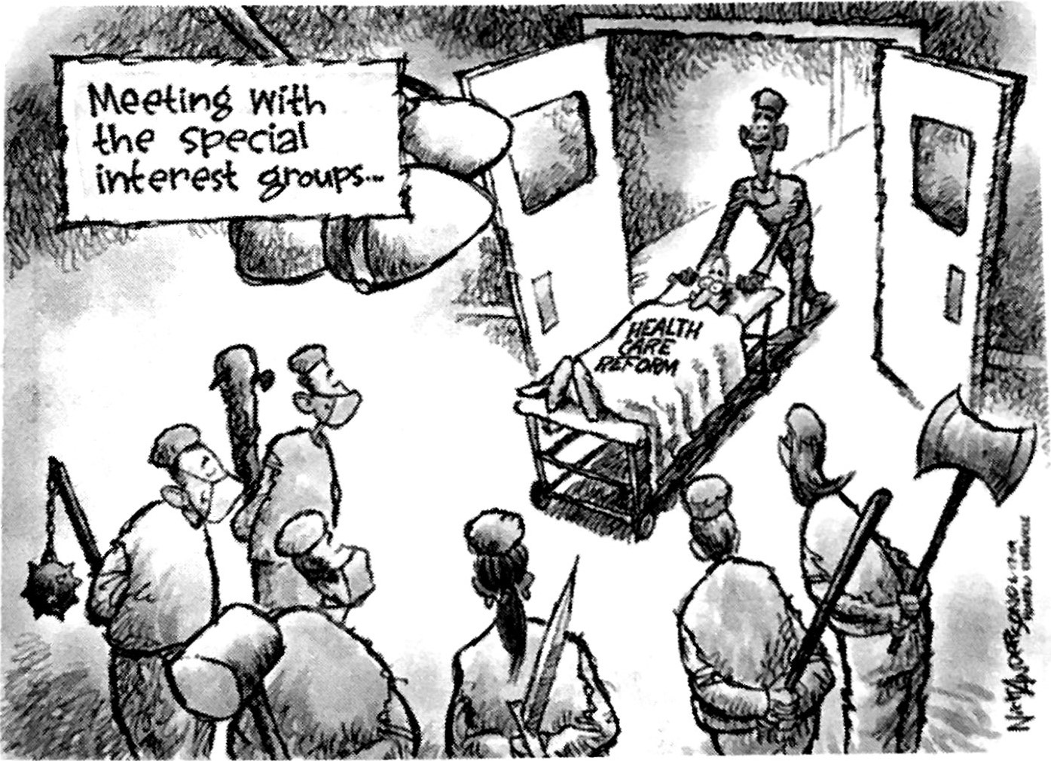

Item 5:
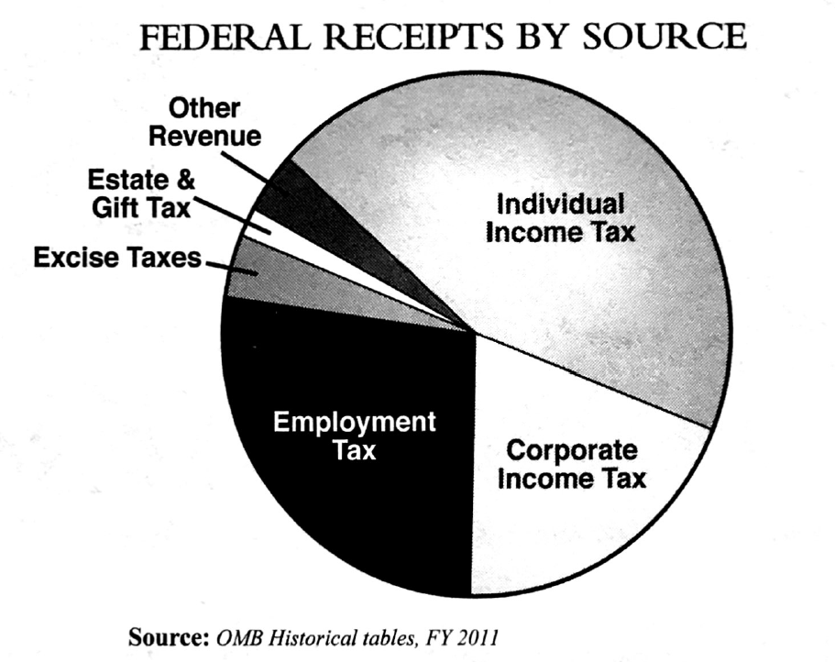

Item 6:
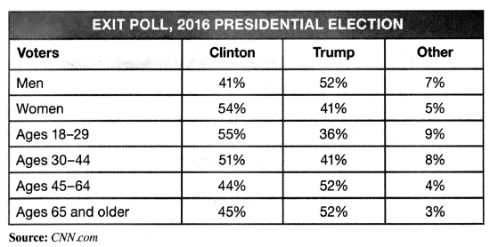

Item 7:
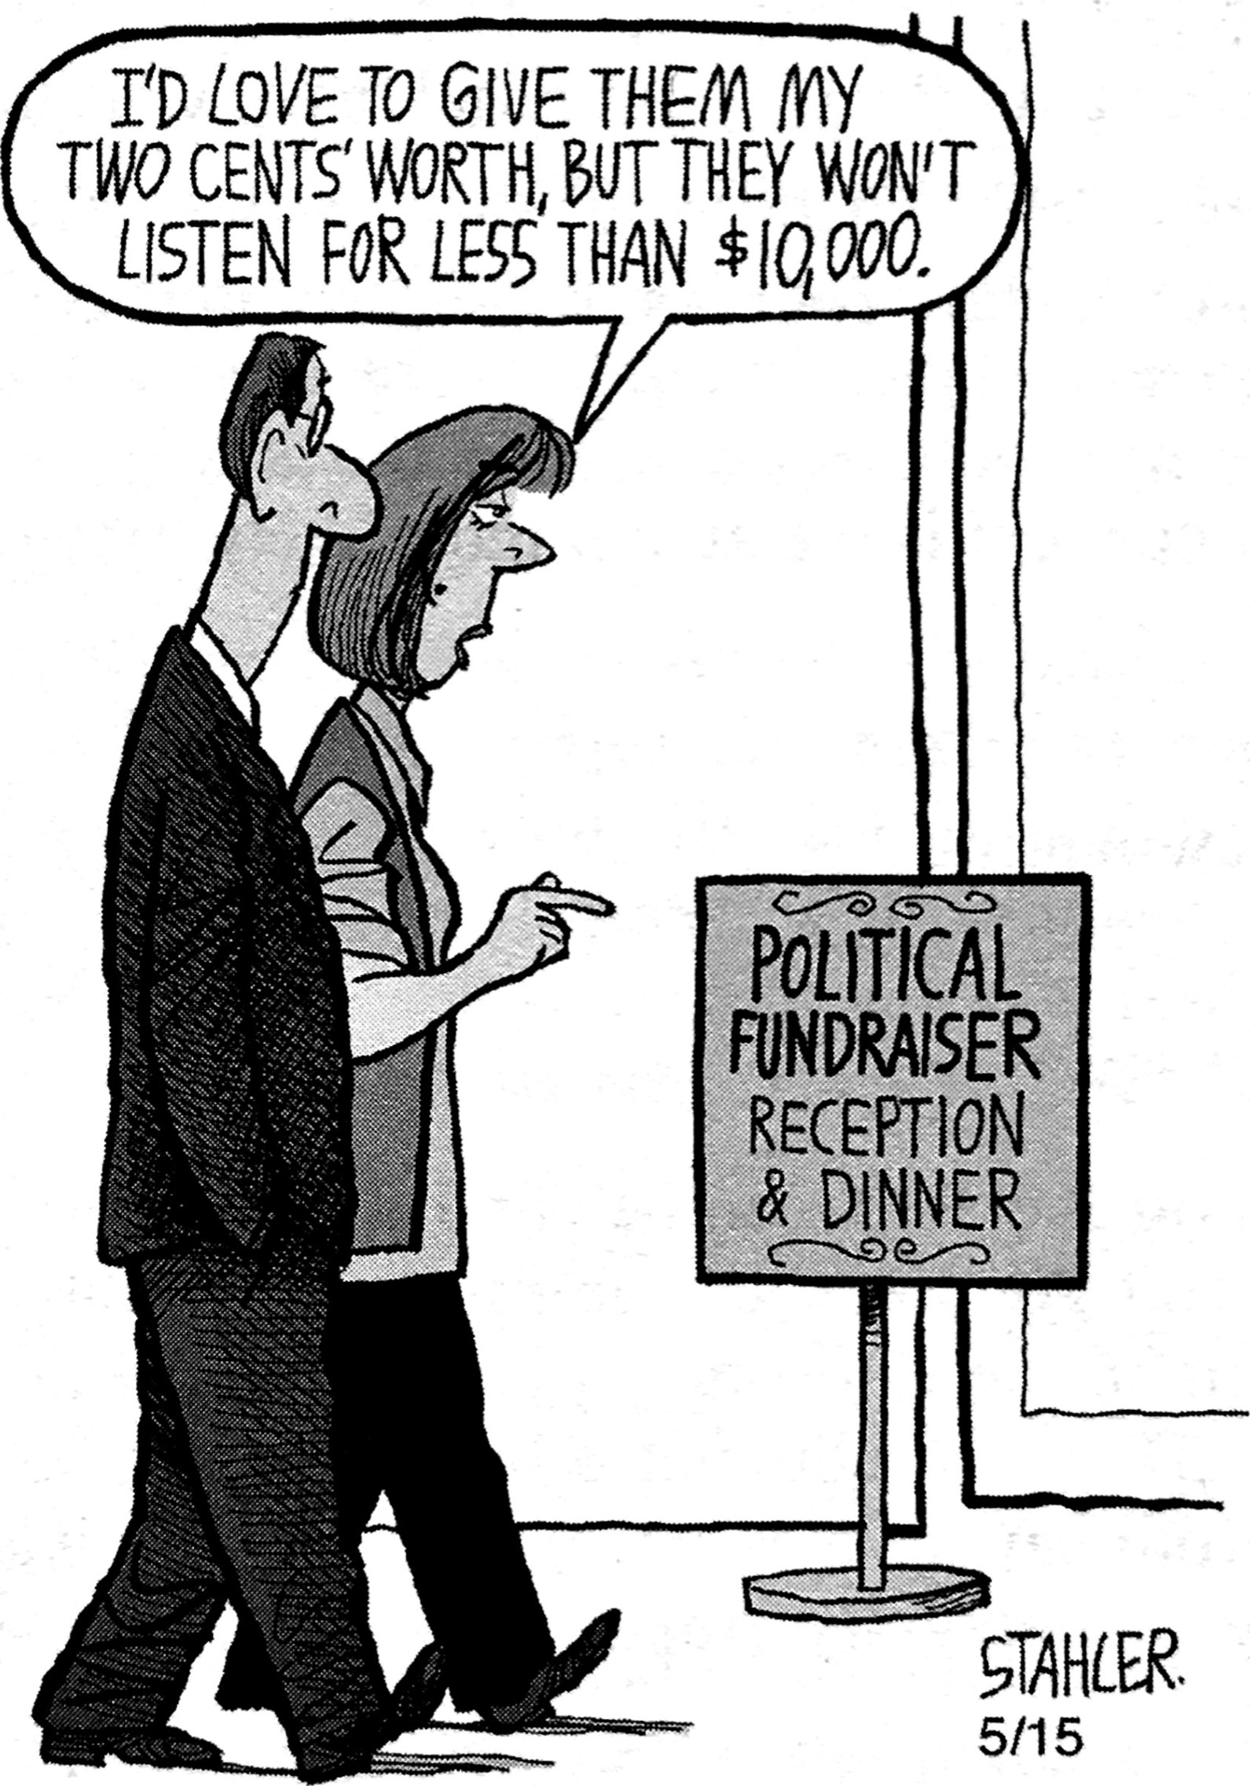

Item 8: In the following table, cross out statements that are not true and circle the statements that are true.
Hint: You should end up with one row that has both the left and right cells circled.
Challengers | Incumbents
Tend to win in a bad economy | Spend less money
Have an easier time raising money because of their fresh appeal | Are viewed skeptically because they have an open voting record
Have generally fewer resources than incumbents | Use the tools of their office to help support their candidacy
Mainly use federal matching money | Coordinate with Super PACs

Item 9: In the following table, cross out statememts that are not true and circle the statements that are true.
Hint: You should end up with one row that has both the left and right cells circled.

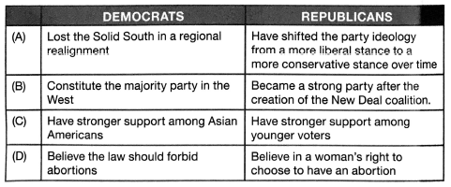
10. Which element of the Electoral College system causes some people’s votes to be discounted? (Hint: Some in Illinois might feel this way…)

11. What tends to happen during midterm Elections to the incumbent’s party?

12. Super PACs can collect _______________ donations from the public and can spend without limit -- but cannot coordinate directly with _____________________.

13. Conservatives typically favor _________________ Economics and _________________ Policy – because they believe that increasing the supply of currency In society will bring down inflation and stimulate the economy.

14. Liberals typically favor ___________________ Economics and ____________________ Policy because they believe that the more revenue a government takes in and spends the better off the economy will be and the better they can fund social programs.

15. In order to decrease the deficit, Democrats would most likely want to increase which type of taxes?
A. Individual Income Tax B. Corporate Income Tax

16. What is a “Push Poll?”

17. Explain “Hard Money” and “Soft Money” and the limits placed on each. Which one is more regulated?

18. Based on the polling data we analyzed in class, which demographic’s voting behavior is the most predictable?
A. Immigrants who become citizens
B. Jewish voters
C. African Americans

19. In your own words, describe “horse race journalism”:

20. In order for a public opinion poll to be valid, it must have a low margin of __________________.

****FOR THE FRQ: Be prepared to discuss…
- Citizens United v. FEC (2010) and McCutcheon v. FEC (2004)
- Citizens United v. FED (2010) and Hobby Lobby v. Burwell (2014)

