Skills Practice - Quantitative Data Analysis

Disciplinary Practice 3: Analyze and interpret quantitative data represented in tables, charts, graph, maps and infographics.

3.a. Describe the data presented | What does this data show?
3.b. Describe patterns and trends in data | - What trends and patterns can you identify from the data?
3.c. Explain patterns and trends in data to draw conclusions | - What conclusions can you draw by comparing the trends you found in the data?  - What is the reasoning behind your conclusion?
3.d. Explain what the data imply or illustrate about political principles, institutions, processes, policies and behaviors | - How does this data relate to a political process?  - What could political parties learn from this data that would affect how they operate?
3.e. Explain possible limitations of the data provided | - What does the data not tell you?
3.f. Explain possible limitations of the visual representation of the data provided | - How does the way the data is presented limit its value?

For this activity, you will work on building your political science analysis skills by analyzing a series of graphs that reflect responses that Americans have made to polls about their ideology.

For each graph, you will walk through the steps in the chart above. As a group, discuss the graph presented and the 6 steps listed above. Then, answer those questions in the chart below each graphic.

Graph 1:
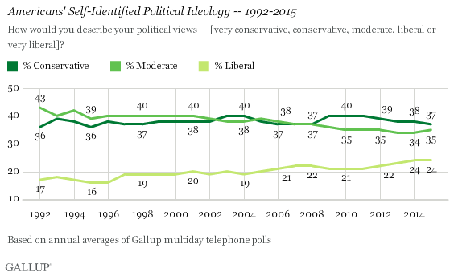

3.a.
3.b.
3.c.
3.d.
3.e.
3.f.

Graph 2:
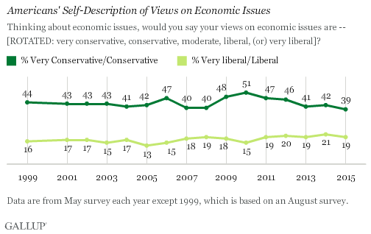

3.a.
3.b.
3.c.
3.d.
3.e.
3.f.

Graph 3:
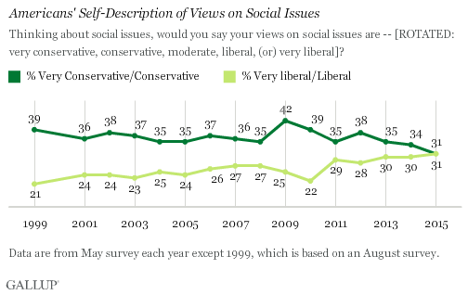

3.a.
3.b.
3.c.
3.d.
3.e.
3.f.

Graph 4:
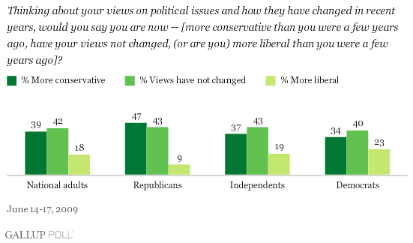

3.a.
3.b.
3.c.
3.d.
3.e.
3.f.

Graph 5:
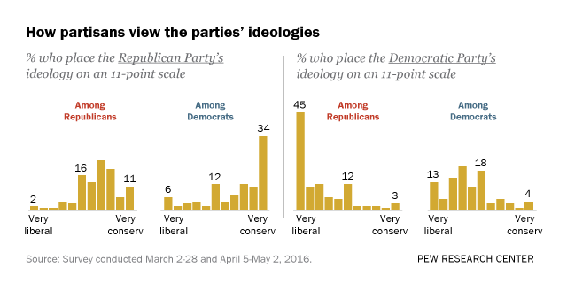

3.a.
3.b.
3.c.
3.d.
3.e.
3.f.

