Name: _________________________________ Period: ____

The Social Psychology of Cast Away: Socialization, Social Isolation, and Coping Strategies

Part I: Sociological/Psychological Concepts: Record the definitions of the following concepts.

Coping Strategy –

Maslow’s Hierarchy of Needs –

Self-Concept –

In the pyramid below, fill in each level of needs according to the notes.
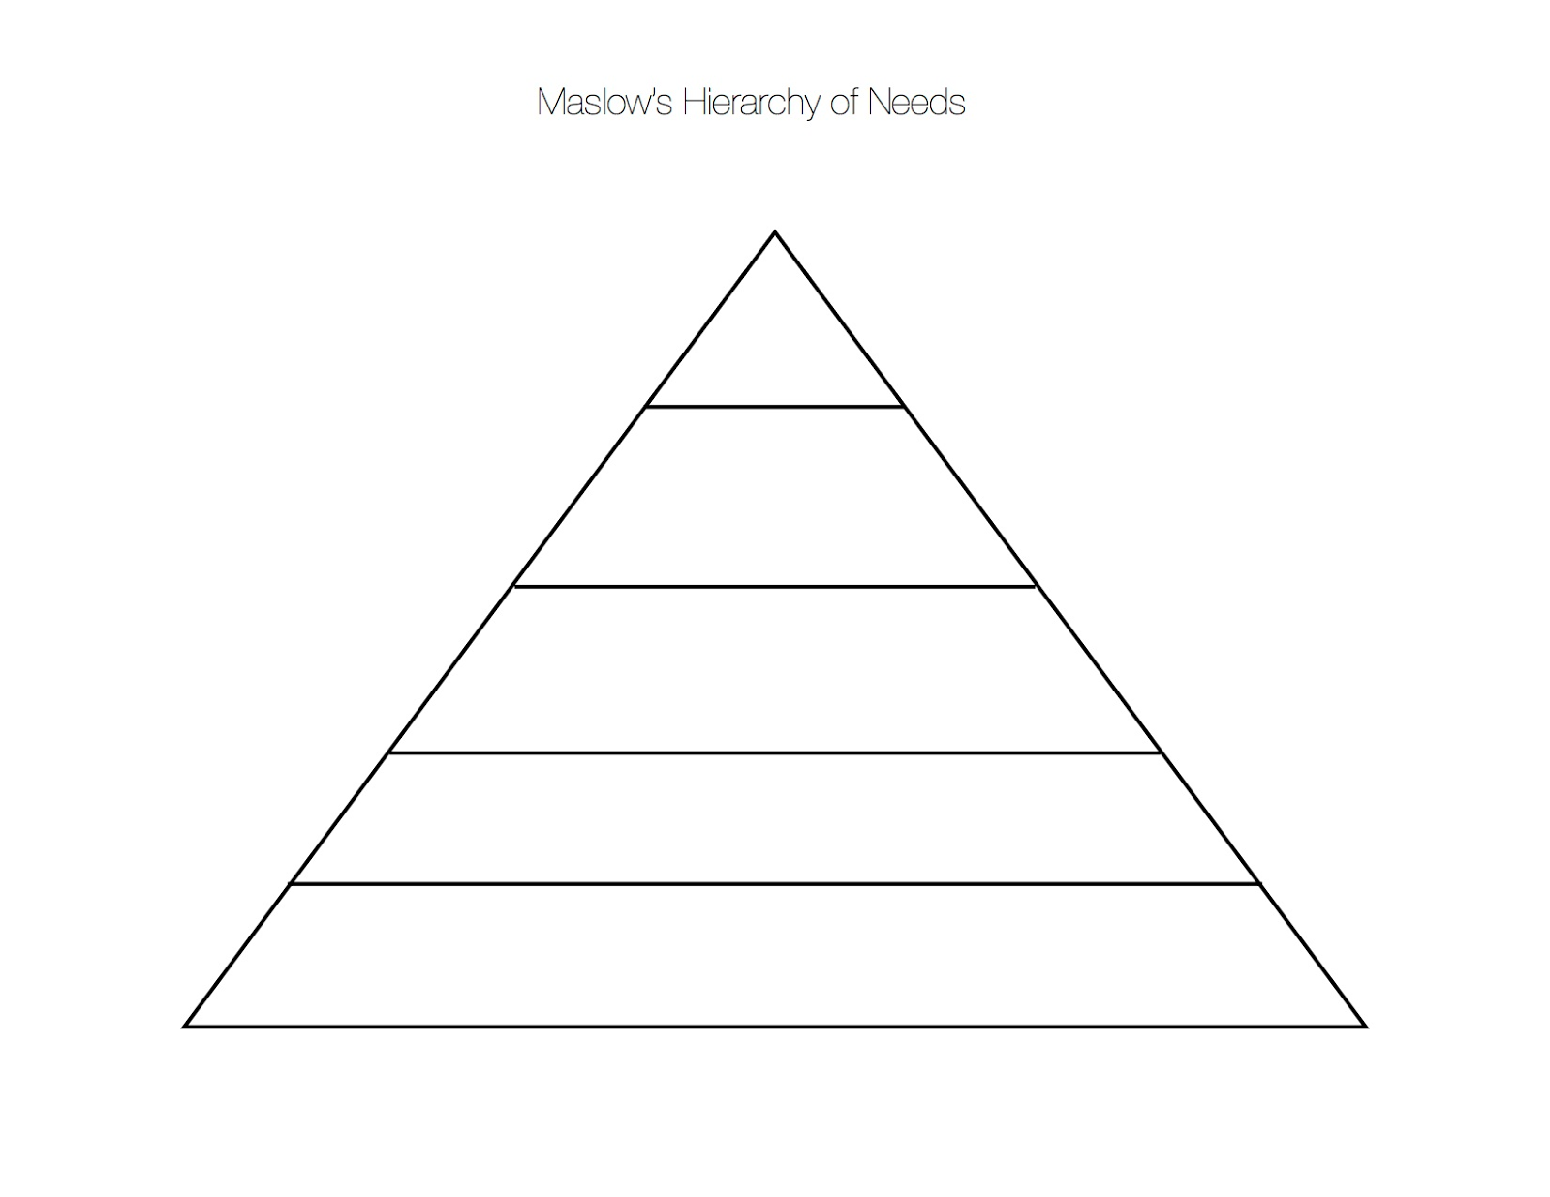

Part II: Film

- What is Chuck’s life like before the island? Who is he as a character? Pay very close attention at the start of the film and be as thorough and detailed as you can (it will help you later).

- On the island, what hardships does Chuck face? Record the hardships and the coping strategy he used to deal with them. Finally, relate it to Maslow’s Hierarchy.

Hardship/Obstacle | Coping Strategy | Need (Maslow’s Hierarchy)

- During his stay on the island, Chuck struggles to maintain his self-concept. How does he attempt to maintain it?

- Throughout his stay on the Island Chuck opens up packages and uses their contents to help him survive. What does the “unopened box” mean to Chuck? What might it represent for him?

- Intelligence is defined as the ability to acquire and apply knowledge and skills. It is also the mental quality consisting of the ability to learn from experience, solve problems, and use knowledge to adapt to new situations. Based on these definitions, would you consider Chuck intelligent based on his ability to adapt to his environment? Explain.

- What purpose did Wilson serve? How did Wilson help Chuck cope with being on the island? What need did he fulfill; particularly, what level in Maslow’s Hierarchy?

- Imagine being isolated for four years and then returning home to a large number of people. Consider which mental illness Chuck might have experienced after returning home. At what point after returning to the United States do we notice this disorder?

- Final Essay (At least three paragraphs): Think about the sociological/psychological term “Self-Concept.” Did Chuck “lose himself” on the Island? Why or why not?
-Did he come back the same person as he left?
-How did he acclimate to social isolation?
-What coping strategies did he use to maintain his psychological constitution (mental health) and his self-concept?
-How did he re-acclimate to society?

____________________________________________________________________________________________________________________________________________________________________________________________________________________________________________________________________________________________________________

____________________________________________________________________________________________________________________________________________________________________________________________________________________________________________________________________________________________________________

____________________________________________________________________________________________________________________________________________________________________________________________________________________________________________________________________________________________________________

____________________________________________________________________________________________________________________________________________________________________________________________________________________________________________________________________________________________________________

____________________________________________________________________________________________________________________________________________________________________________________________________________________________________________________________________________________________________________

____________________________________________________________________________________________________________________________________________________________________________________________________________________________________________________________________________________________________________

____________________________________________________________________________________________________________________________________________________________________________________________________________________________________________________________________________________________________________

____________________________________________________________________________________________________________________________________________________________________________________________________________________________________________________________________________________________________________

____________________________________________________________________________________________________________________________________________________________________________________________________________________________________________________________________________________________________________

____________________________________________________________________________________________________________________________________________________________________________________________________________________________________________________________________________________________________________

____________________________________________________________________________________________________________________________________________________________________________________________________________________________________________________________________________________________________________

____________________________________________________________________________________________________________________________________________________________________________________________________________________________________________________________________________________________________________

____________________________________________________________________________________________________________________________________________________________________________________________________________________________________________________________________________________________________________

____________________________________________________________________________________________________________________________________________________________________________________________________________________________________________________________________________________________________________

