Name: ________________________ Period: _____

  - – I See Dead People: History of Sociology & Classical Sociological Theorists
Take notes by following along and filling in the blanks. Also, based on the slides and explanations Mr. Sterchi gives during the lecture, write in any additional information that might help you on an exam.

Sociology is…
- Sociology is a _______________________, which is the study of the human/social world.

- Sociology uses ________________-based research to explain the social world.

- Unlike sociologists, most people rely on their _____________________ to understand the world around them. This can be misleading though.

Examples:

The European Period…
- For the first half of the history of sociology, the field was dominated entirely by __________________________________.

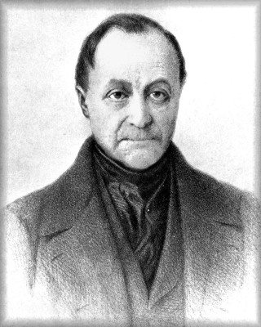
European Sociologists
Name:
Nationality:

___________ of Sociology
Key Concepts
1.

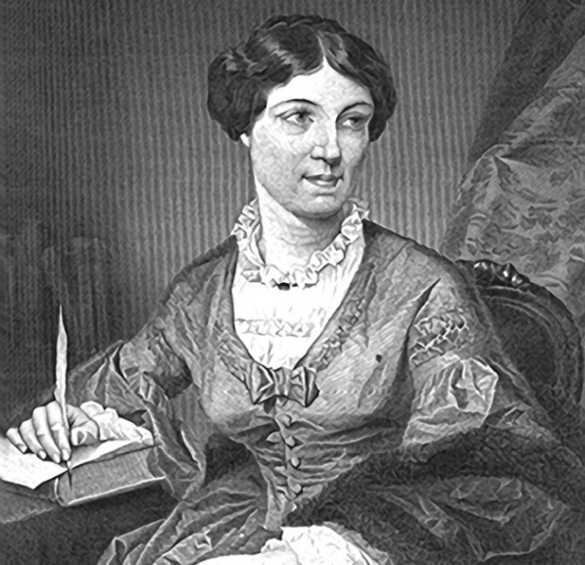
Name:

Nationality:

Key Contributions:
1.

2.

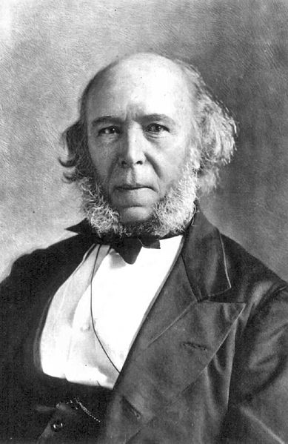
Name:

Nationality:

Key Concepts:
1.

2.

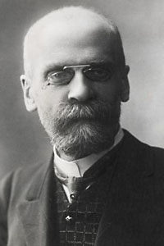
Name:

Nationality:

Key Concepts:
1.

2.

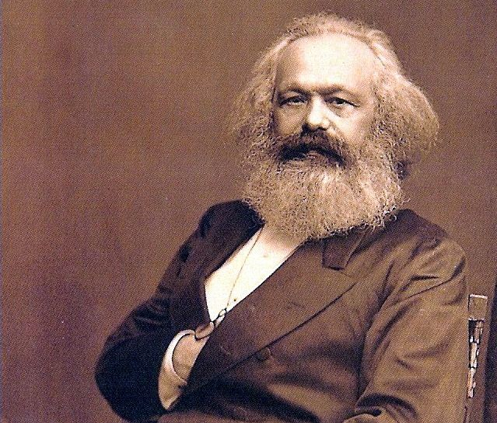
Name:

Nationality:

Key Concepts:
1.

2.

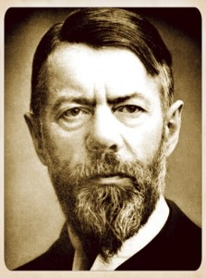
Name:

Nationality:

Key Concepts:
1.

2.

Pioneered research techniques that tried to eliminate ________________________.

Sociology in the US…
- The field of sociology changed dramatically in the early 20th century

- American sociology was established as the _________________________ --- most notably the ______________________________ at the ___________________________________________________________.

- Old/European methods focused on _________________________________

- New/American methods focused on studying society ______________________________ using ____________________________________________________________.

George Herbert Mead was the father of ________________________________.
W.E.B. DuBois was the first African-American to _________________________.

Summary: In one sentence each, explain which theorists founded which sociological perspective.

1.

2.

3.

