Name: _____________________________________________ Period: _____

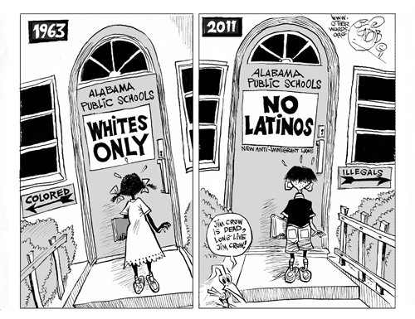

- Which Civil Rights Movement does this cartoon fit in with?

- What issue is being addressed?

- What do you think the author’s message is? Cite evidence from the cartoon to explain your answer.

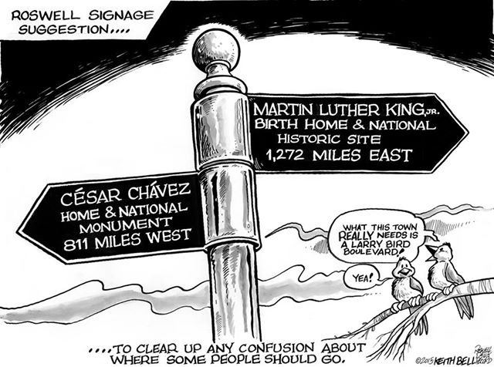

- Which Civil Rights Movement does this cartoon fit in with?

- What issue is being addressed?

- What do you think the author’s message is? Cite evidence from the cartoon to explain your answer.

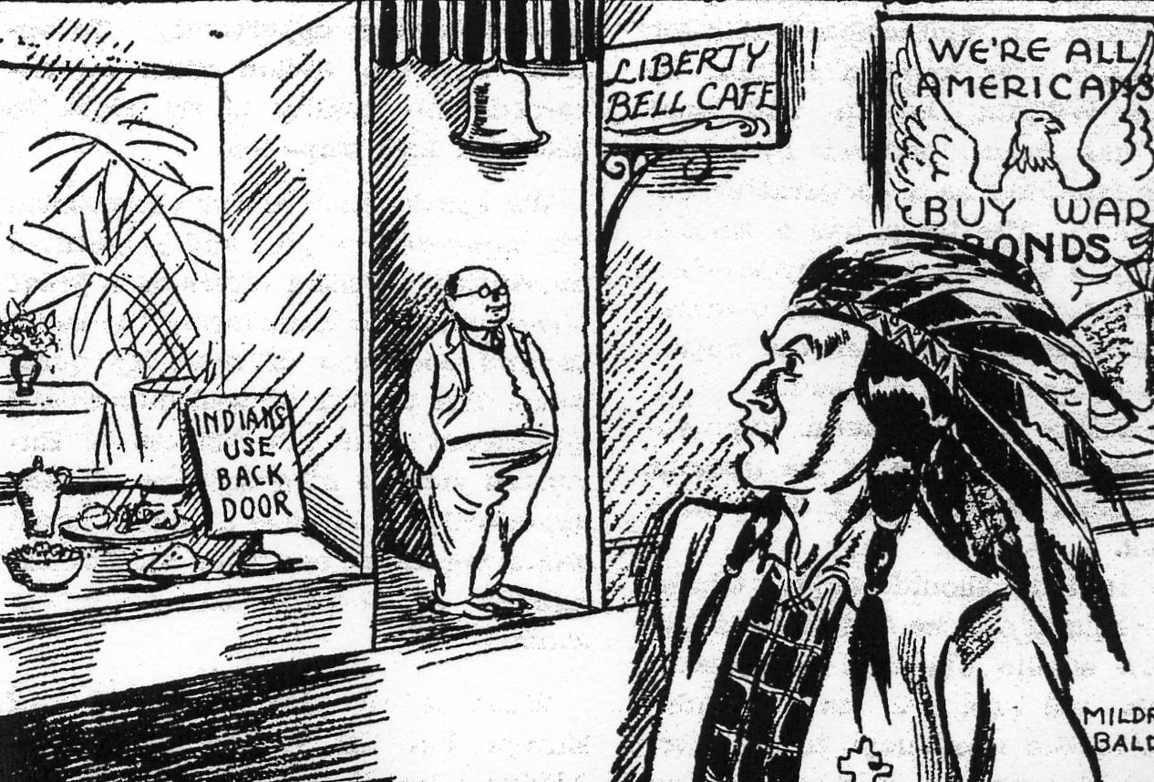

- Which Civil Rights Movement does this cartoon fit in with?

- What issue is being addressed?

- What do you think the author’s message is? Cite evidence from the cartoon to explain your answer.

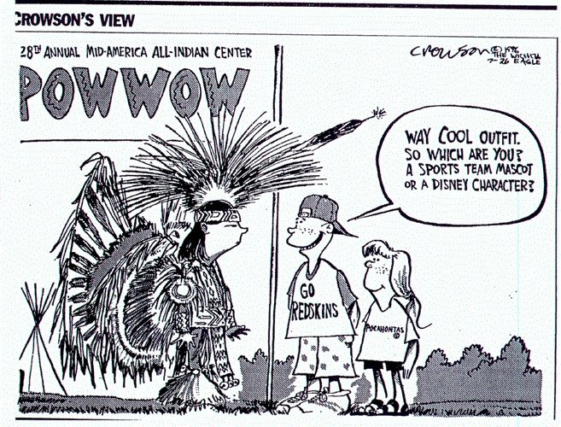

- Which Civil Rights Movement does this cartoon fit in with?

- What issue is being addressed?

- What do you think the author’s message is? Cite evidence from the cartoon to explain your answer.

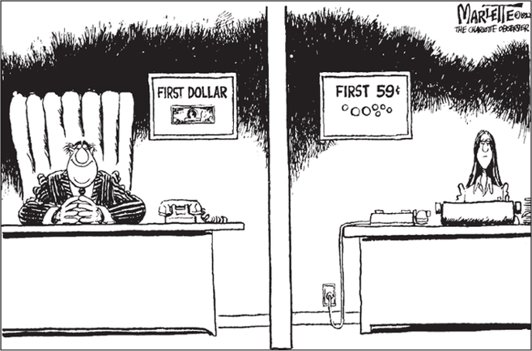
- Which Civil Rights Movement does this cartoon fit in with?

- What issue is being addressed?

- What do you think the author’s message is? Cite evidence from the cartoon to explain your answer.

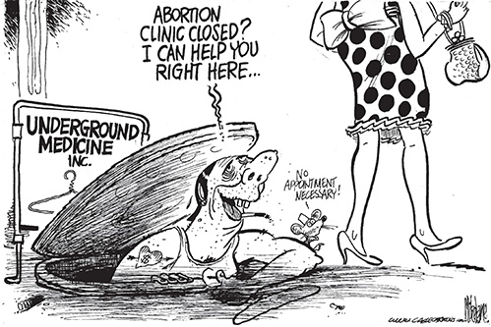
- Which Civil Rights Movement does this cartoon fit in with?

- What issue is being addressed?

- What do you think the author’s message is? Cite evidence from the cartoon to explain your answer.

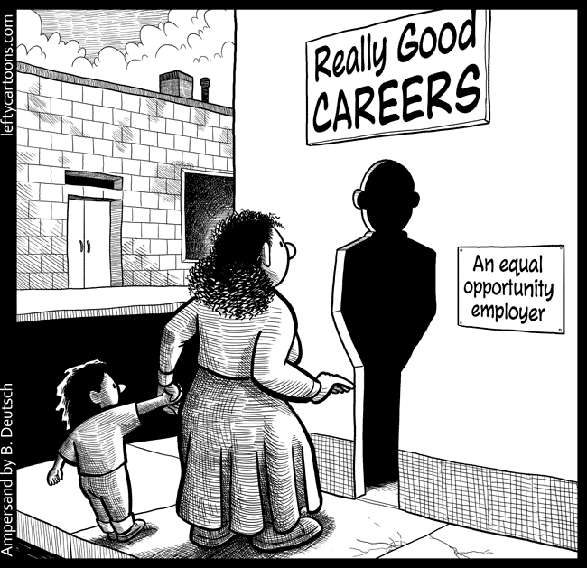
- Which Civil Rights Movement does this cartoon fit in with?

- What issue is being addressed?

- What do you think the author’s message is? Cite evidence from the cartoon to explain your answer.

